**Test cases**

* Testing the admin signing in correctly if user name and password matches correct admins one then admin can sign in (unit testing)

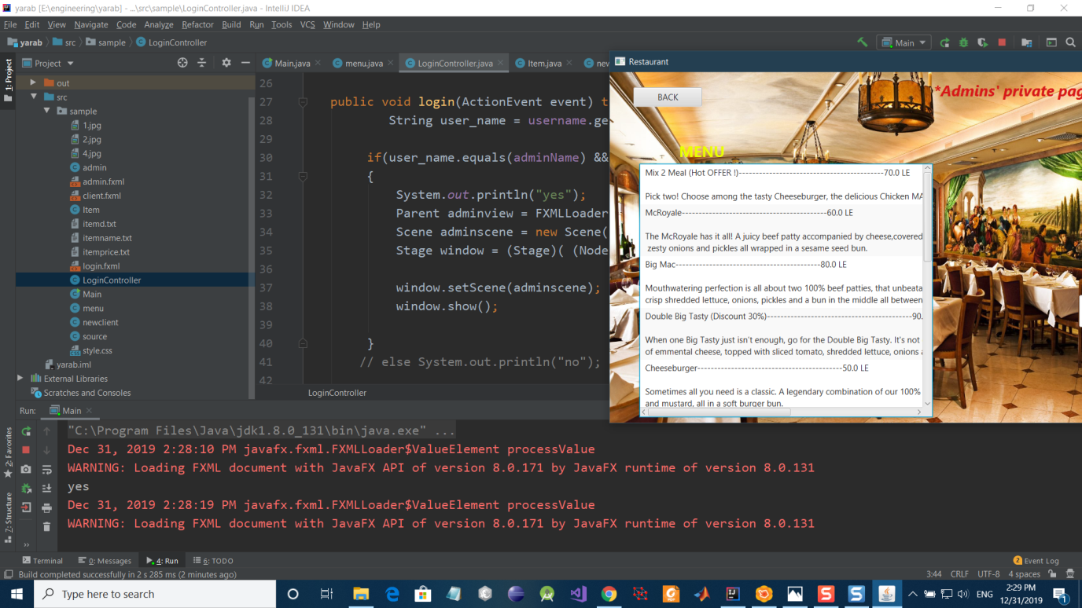

* Testing class menu functions (unit testing)

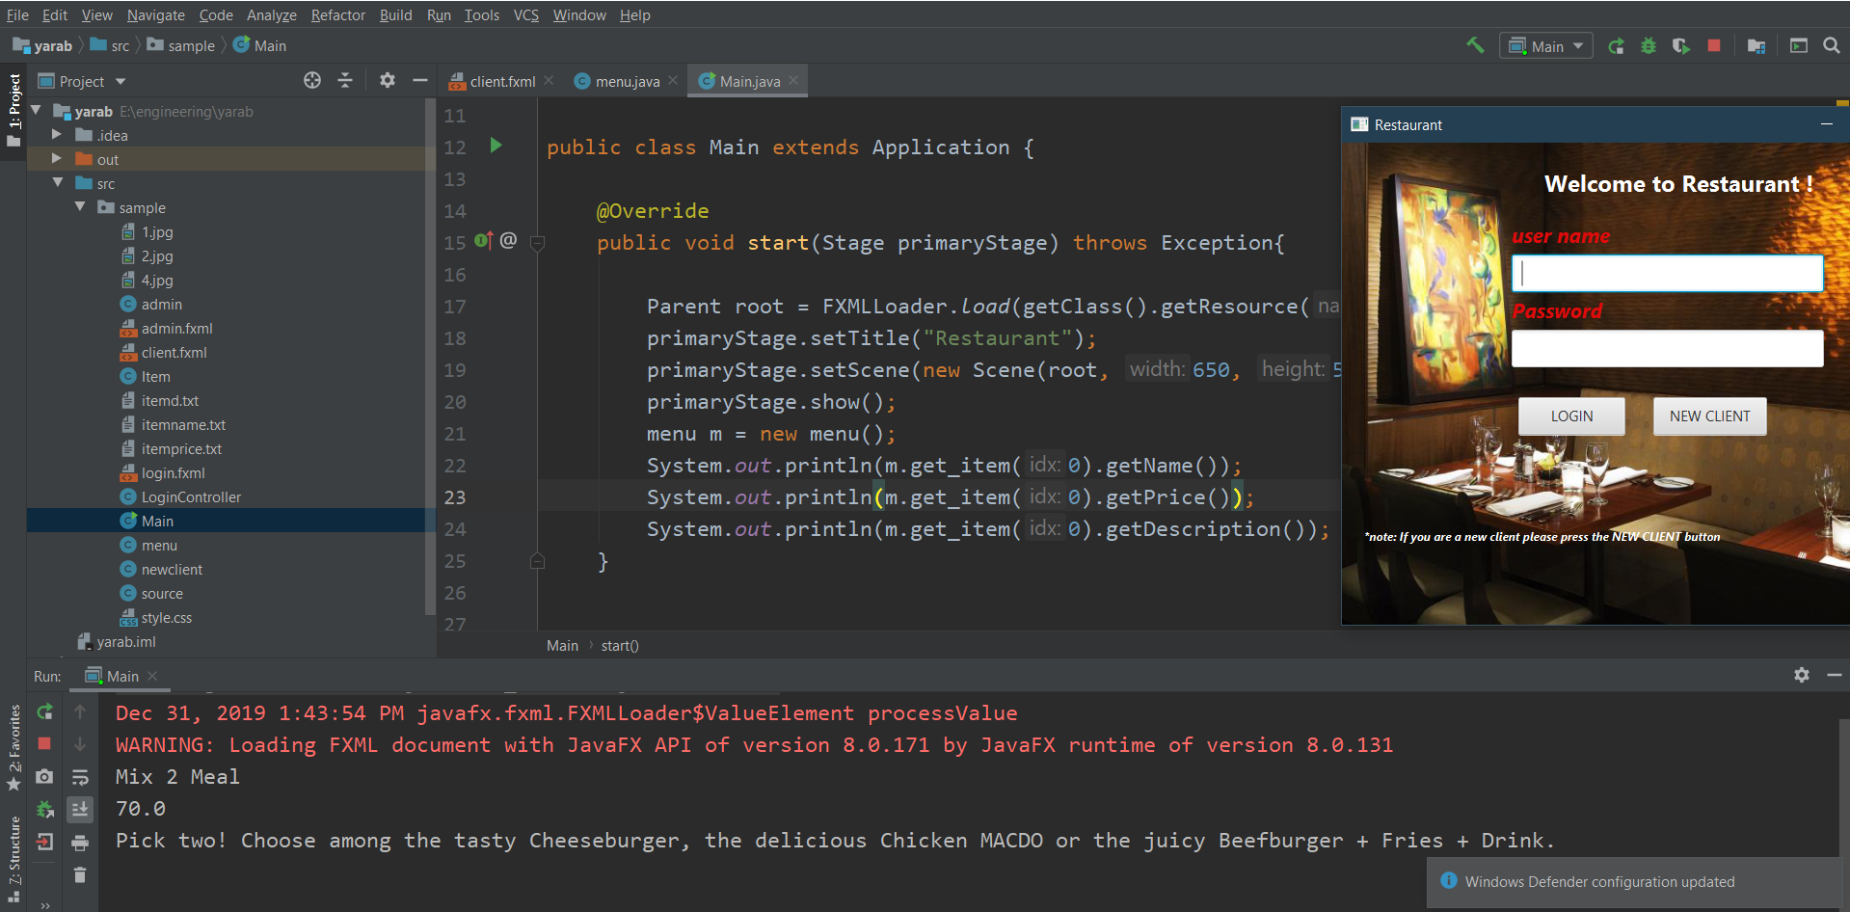

* Testing item class(unit testing)

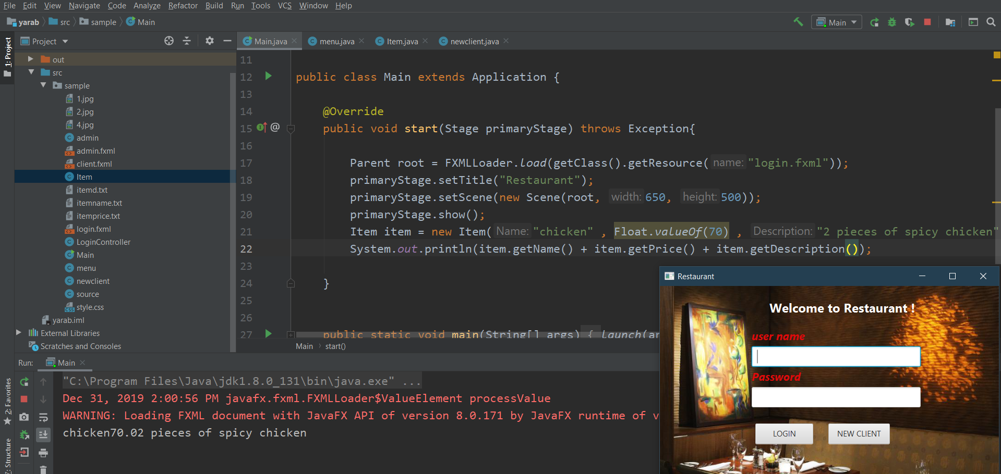

* Testing items added correctly in menu(unit testing)

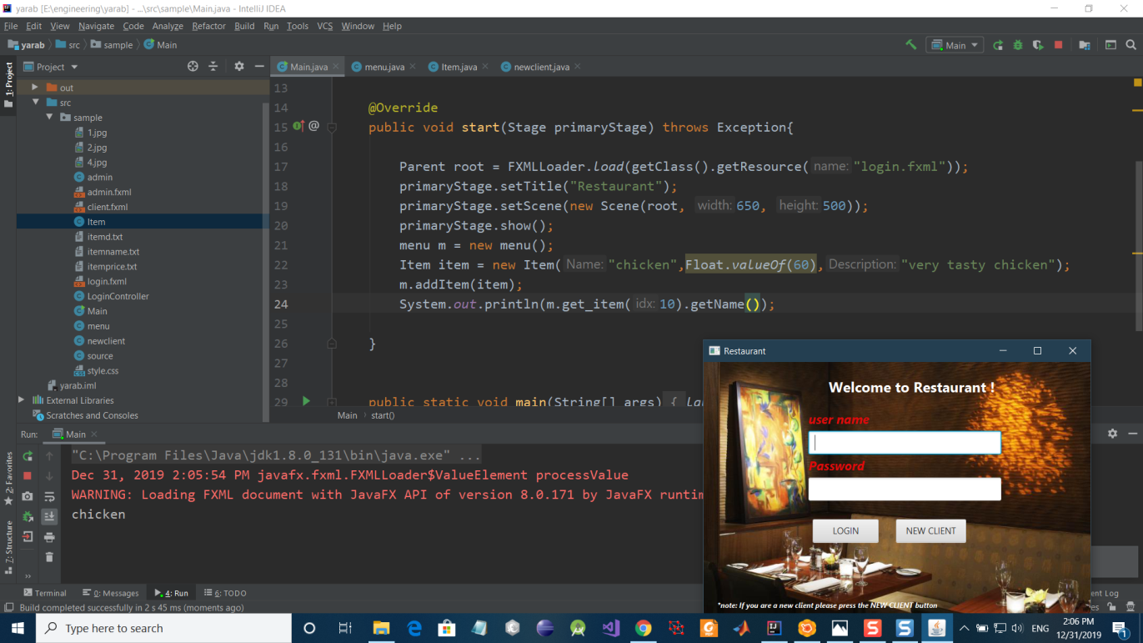

* Testing client button action (system testing)

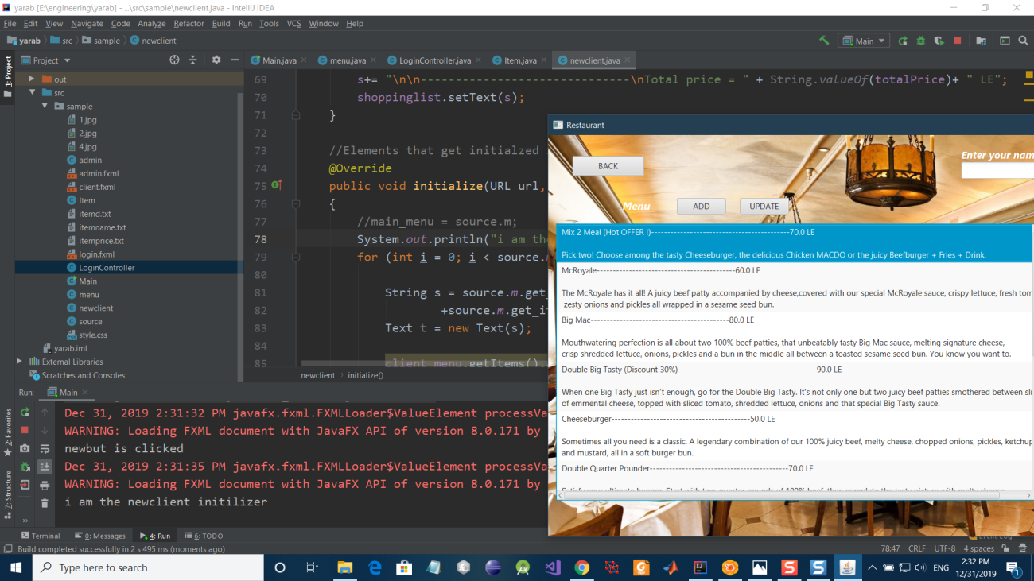

* Testing adding items to shopping list (unit testing)

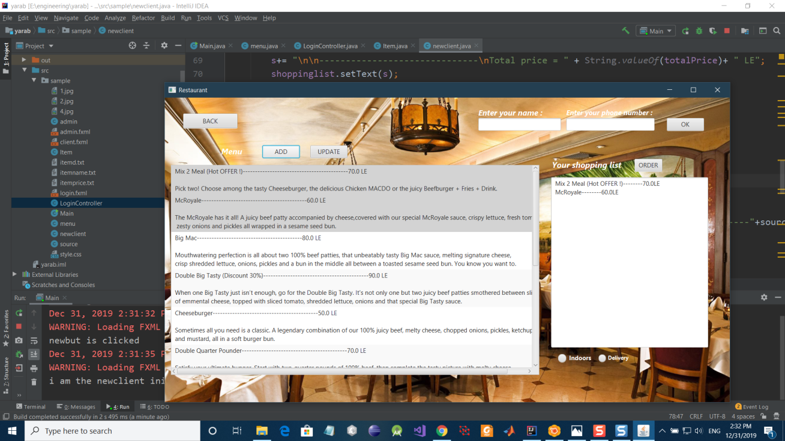

* Testing indoor order calculation after adding taxes to total order(unit testing)

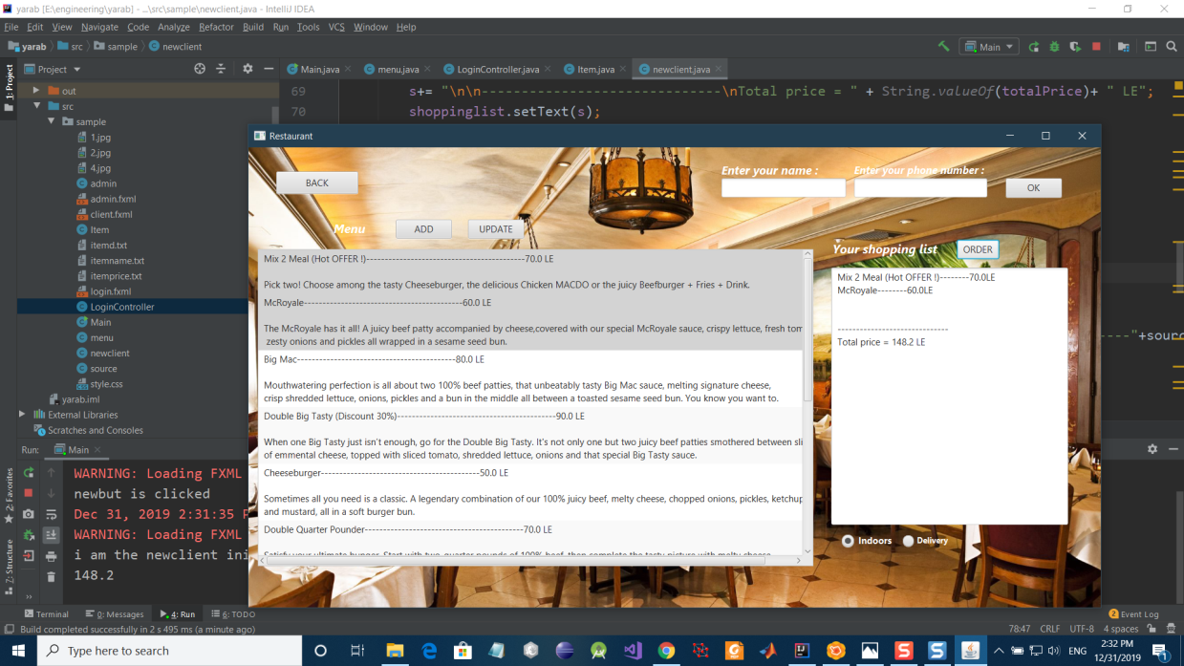

* Testing delivery order after adding taxes and delivery cost to total price(unit testing)

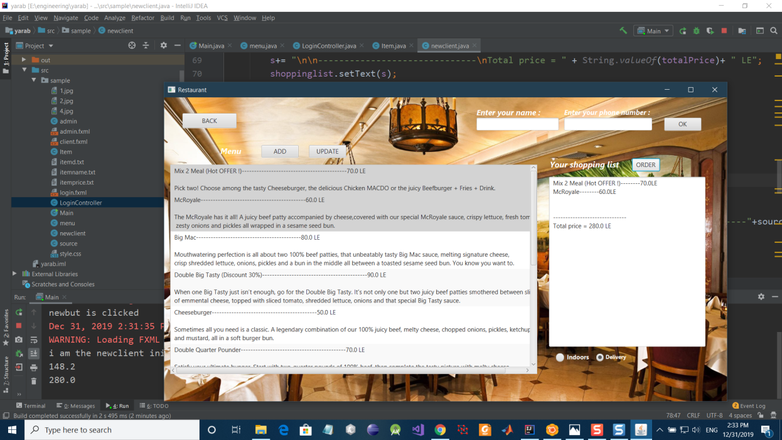

* Testing updating of menu function (unit testing)

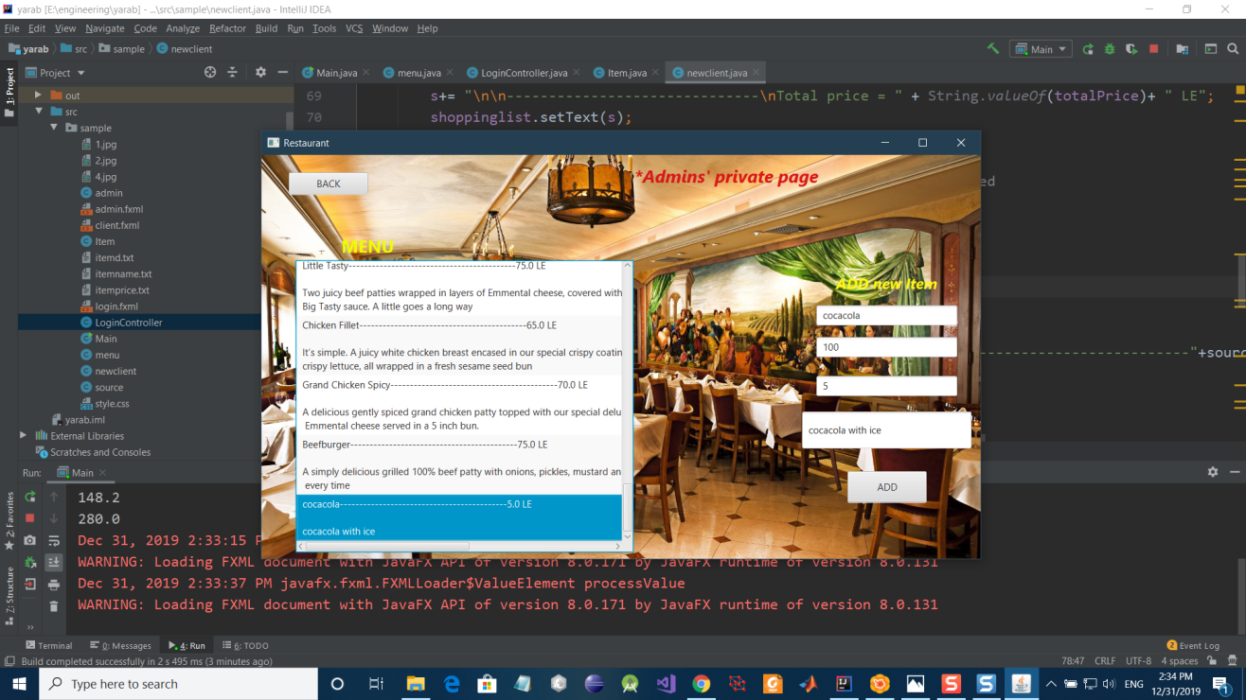

* Testing if menu updated in clients page(system testing)

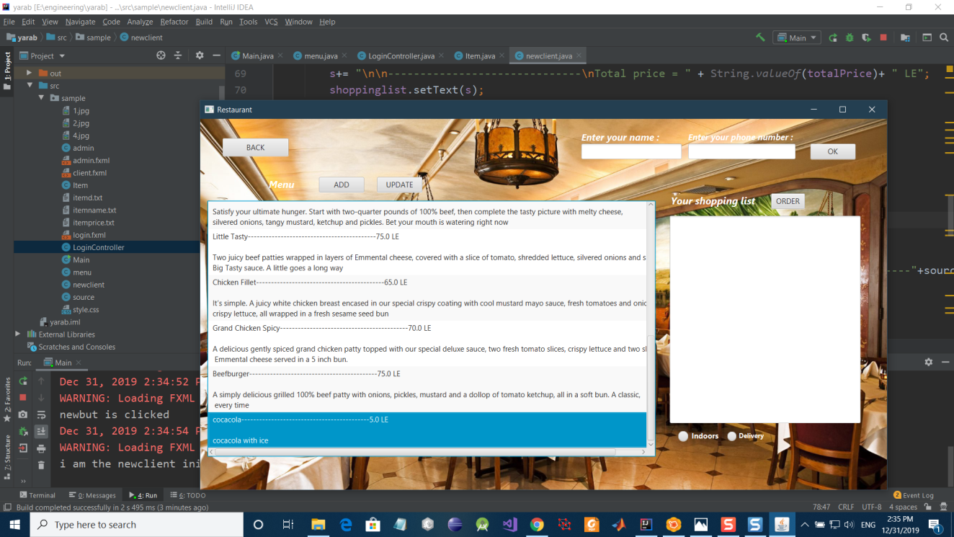

* Testing menu get_size function(unit testing)

